(AND gate)
Pin 1 | Pin 2 | Output
0 | 0 | 0
0 | 1 | 0
1 | 0 | 0
1 | 1 | 1

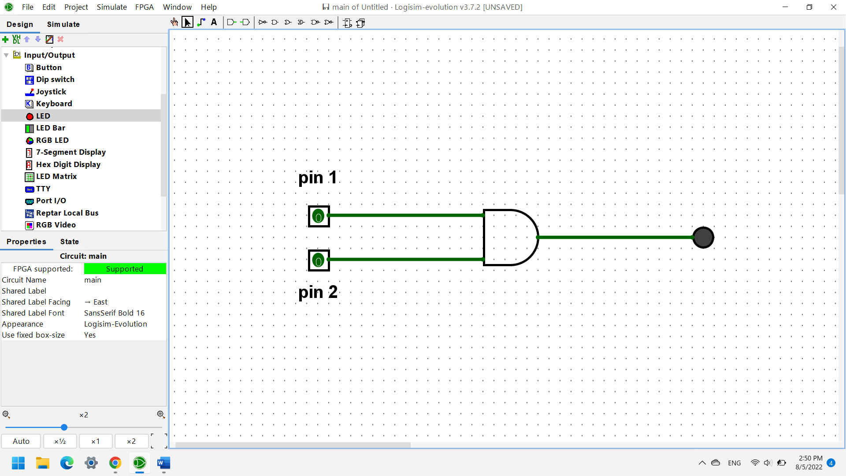

(NOT gate)
Pin | Output
0 | 1
1 | 0

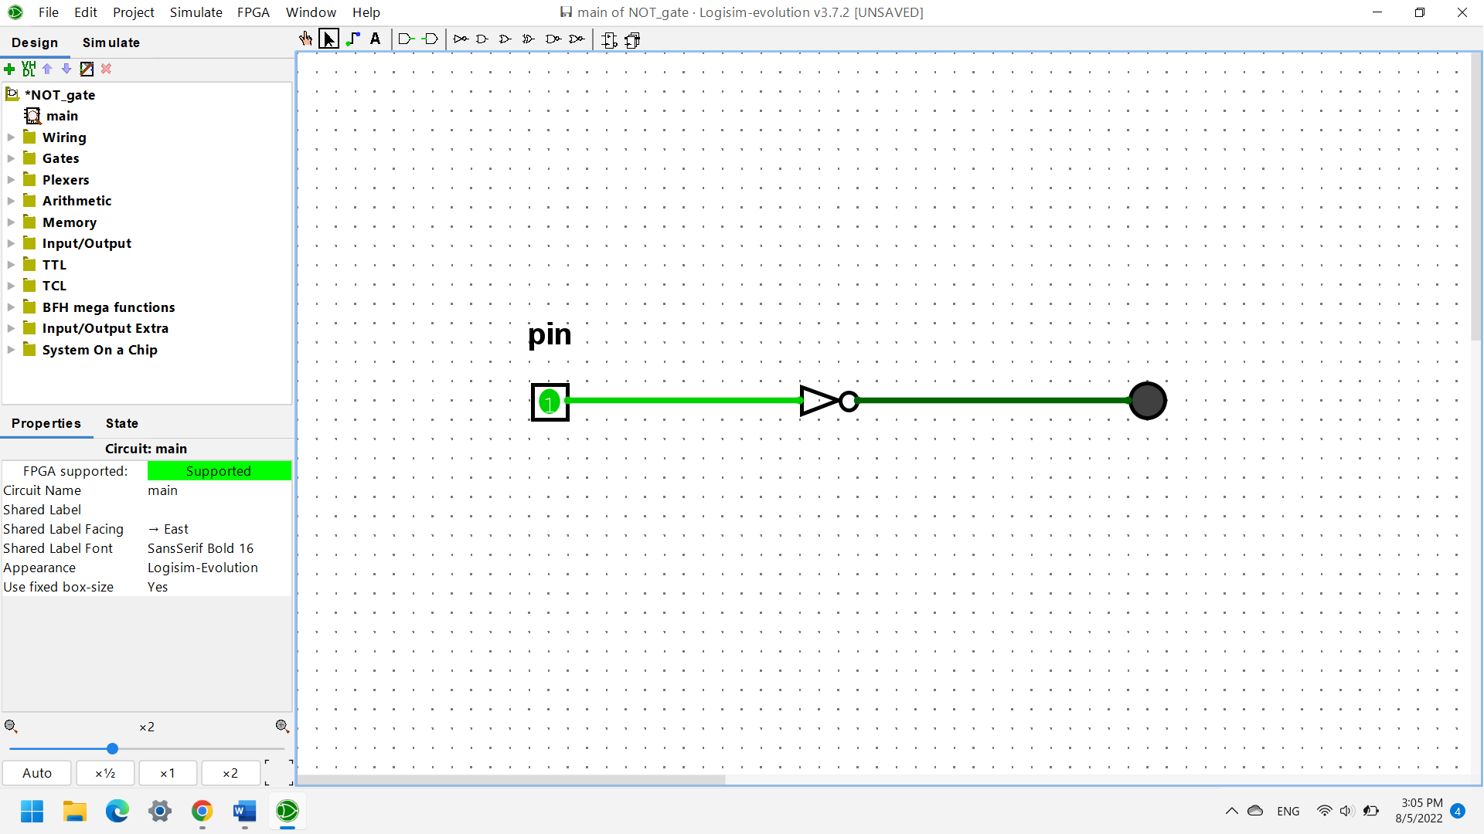

(NAND gate)
Pin 1 | Pin 2 | Output
0 | 0 | 1
0 | 1 | 1
1 | 0 | 1
1 | 1 | 0

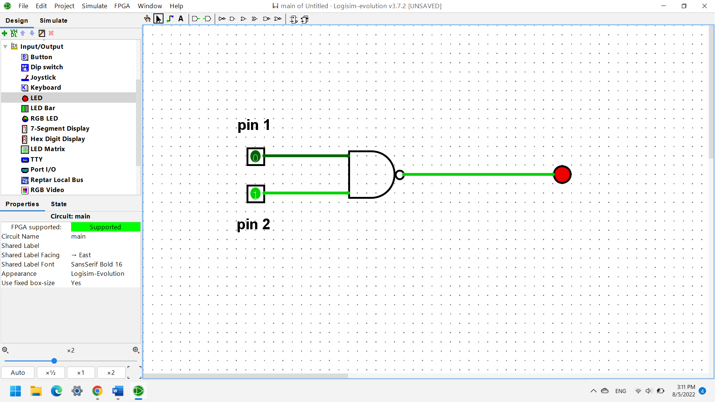

(Half-adder)
Input 1 | Input 2 | Sum Output | Carry Output
0 | 0 | 0 | 0
0 | 1 | 1 | 0
1 | 0 | 1 | 0
1 | 1 | 0 | 1

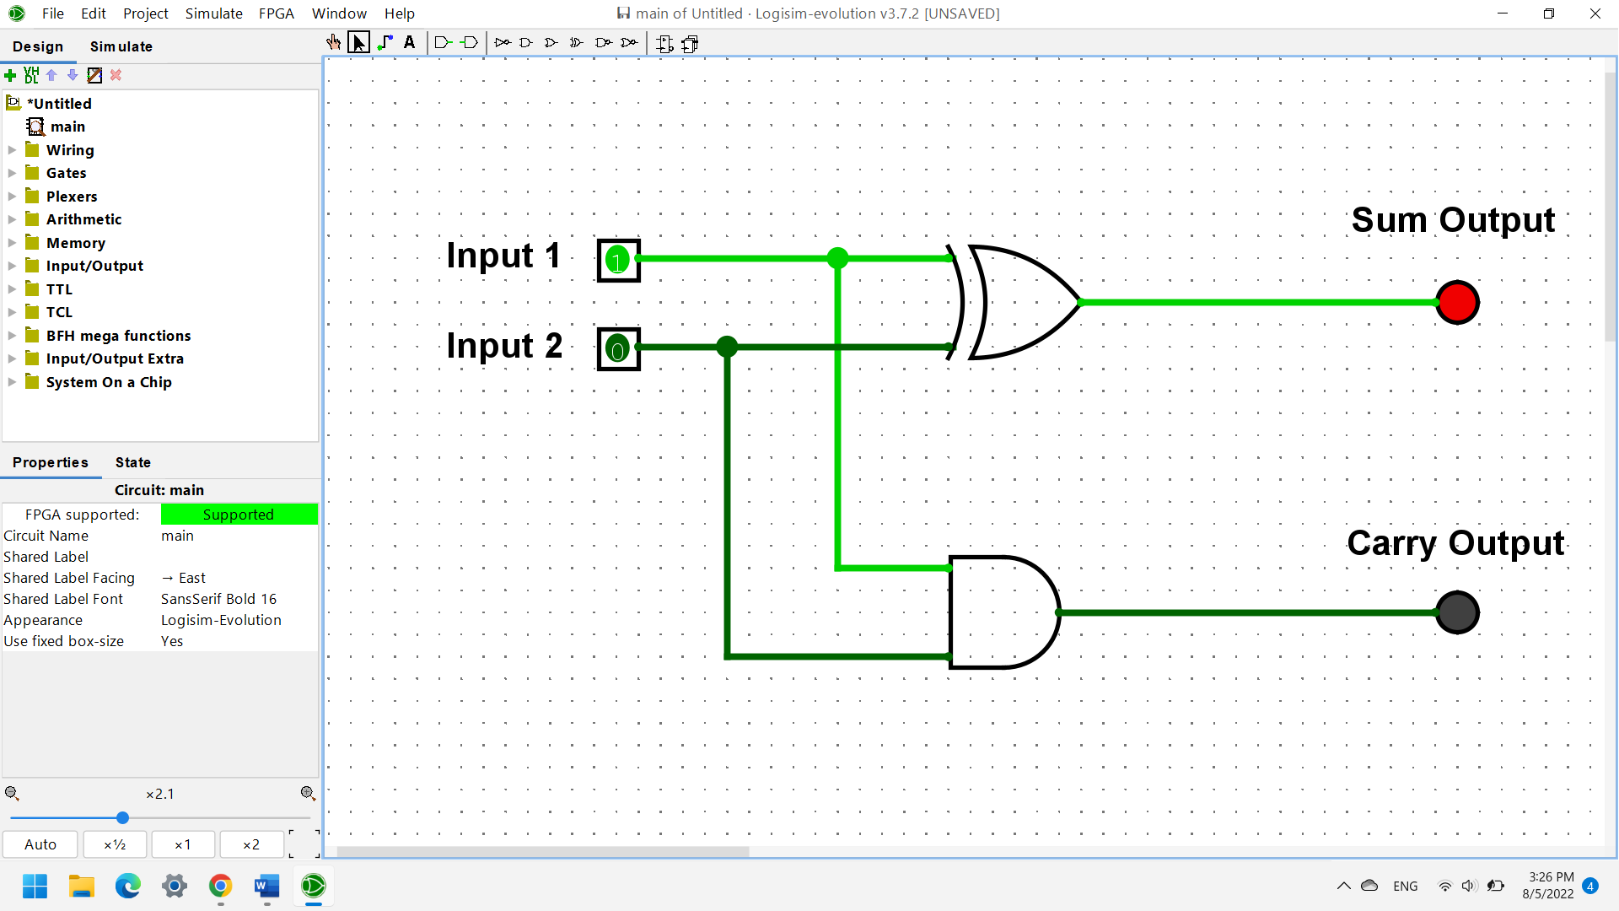

(Full-adder)
Input 1 | Input 2 | Carry in | Sum Output | Carry Output
0 | 0 | 0 | 0 | 0
0 | 1 | 0 | 1 | 0
1 | 0 | 0 | 1 | 0
1 | 1 | 0 | 0 | 1
0 | 0 | 1 | 1 | 0
0 | 1 | 1 | 0 | 1
1 | 0 | 1 | 0 | 1
1 | 1 | 1 | 1 | 1

